**Launch an Instance in a Placement Group**

* **Creating a placement group**
* Click on Create Placement Group

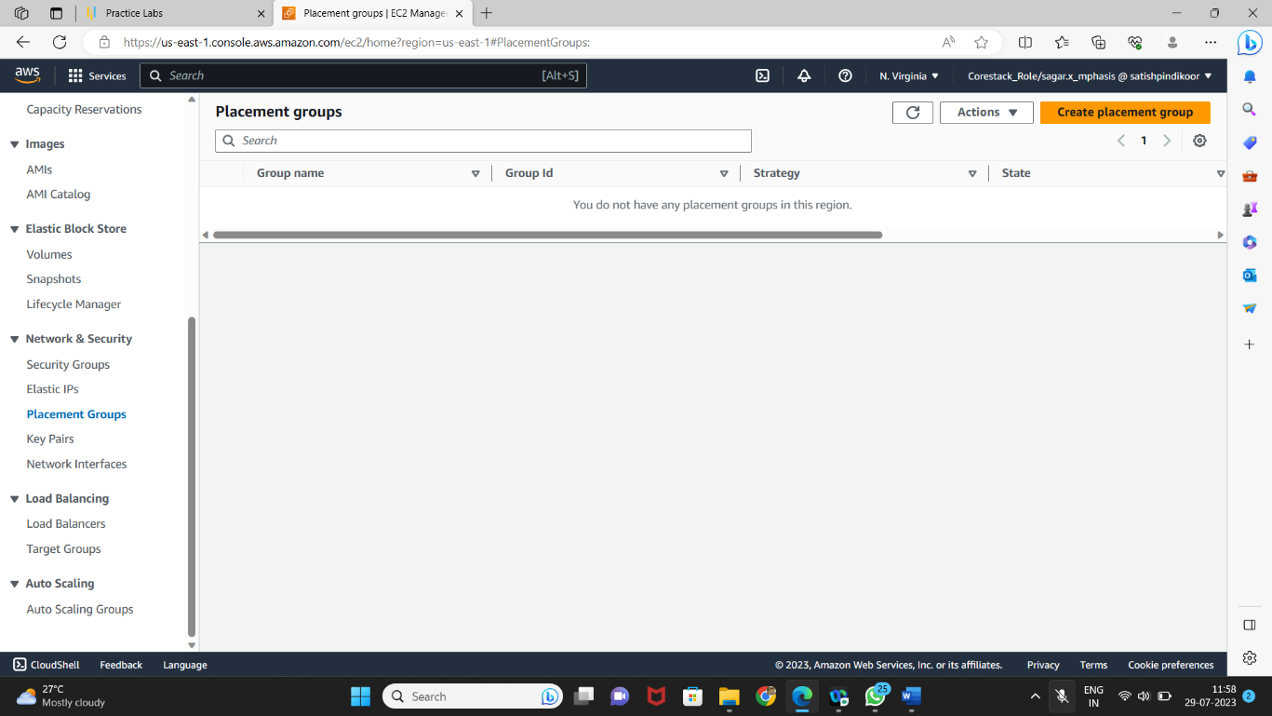

* Provide a name and strategy

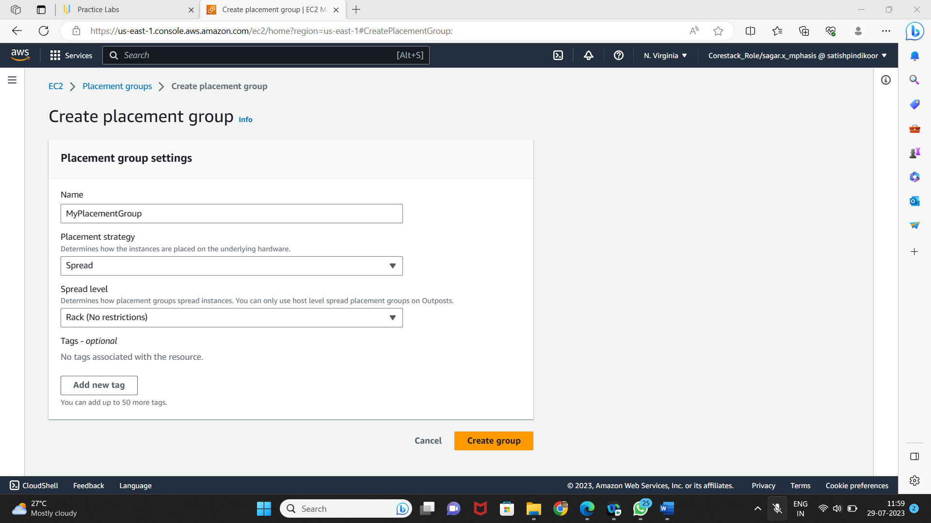

* **Launching an instance in the placement group**
* Launch the new EC2 instance

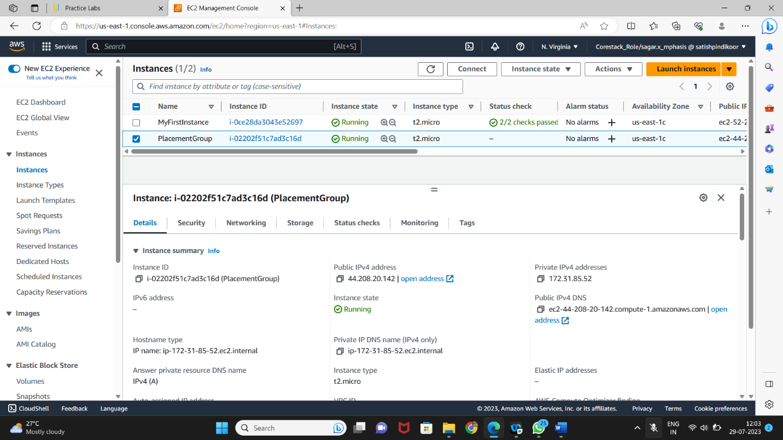

* Select the placement group



* Verify the placement group of the instance

